Heart Disease Prediction

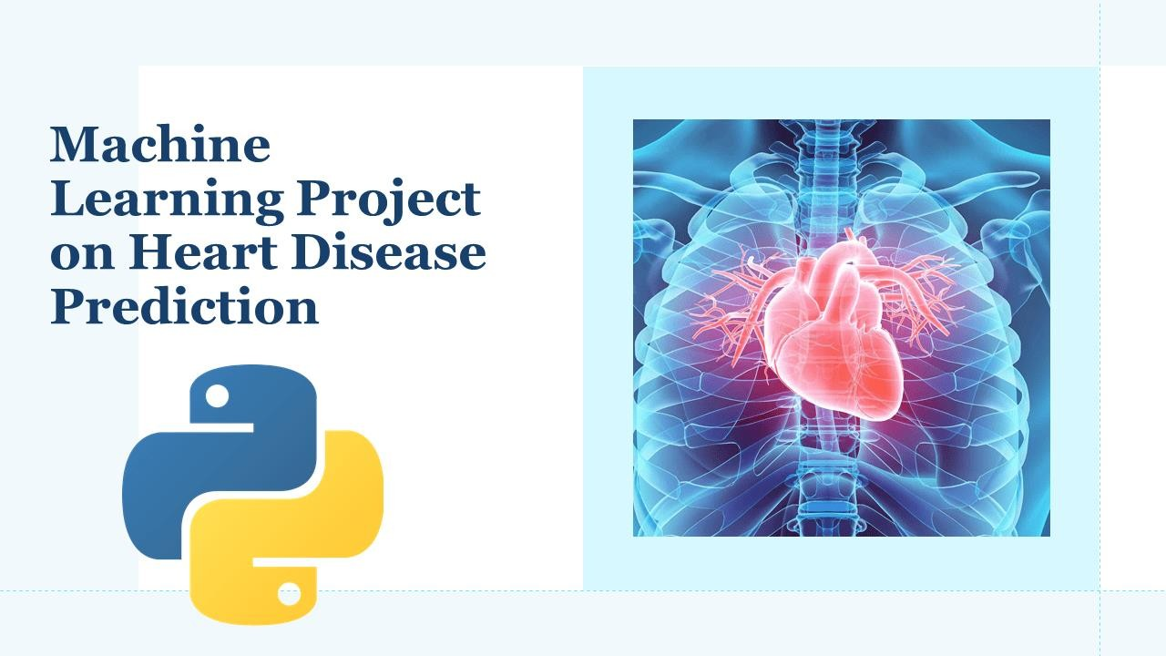

**Abstract:**

By degrees the instances of heart diseases are growing at a quick rate and it’s very Important and related to predict any such diseases in advance. This diagnosis is a difficult task i.e. it should be achieved precisely and efficiently.

CardioCare is a web application to forecast the presence or absence of heart disease. With an in-built and accessible interface, CardioCare enables healthcare providers and individuals to easily collect relevant patient data and get reliable predictions. Such information, if predicted well in advance, can provide important intuitions to doctors who can then adapt their diagnosis and dealing per patient basis. By holding advanced machine learning techniques CardioCare aims to improve the accuracy and efficiency of heart disease diagnosis, making it accessible to everyone. This project gives us significant knowledge that can help us to predict the patients with heart disease.

## Problem Statement:

Finding out heart disease accurately is essential for effective treatment and patient well-being. However, traditional methods are often time-consuming and subjective, focusing on the need for an automated system using machine learning. These conventional approaches can lead to inconsistencies, delays, and high costs due to specialized equipment. Accessibility to cardiac diagnostics is limited in remote areas, hindering swift and accurate diagnoses.

Complex cardiac conditions and different data sources create challenges for healthcare practitioners. Lack of user-friendly decision support tools further complicates efficient analysis. This results in incorrect diagnoses and delayed treatments, impacting patient care.

A solution is needed that predicts the likelihood of severe heart issues using machine learning. This approach can process data rapidly and accurately, automating diagnostics and revolutionizing heart disease detection. This system reduces subjectivity, improves uniformity, and cuts costs by eliminating the need for specialized facilities. It's particularly beneficial in underprivileged regions.

Healthcare providers obtain from this system, making knowledgeable decisions promptly for better patient outcomes. Integration of data sources and user-friendly tools empowers practitioners and enhances diagnoses, improving overall patient care.

So, the challenge of accurate heart disease detection requires creative solutions. Machine learning offers promise, automating procedure, ensuring consistency, and enhancing decision-making. This solution has the potential to reshape cardiac diagnostics, leading to better patient outcomes and efficient healthcare delivery.



## Market/Customer/Business Need Assessment:

1. **Market Need Assessment-**
   * Cardiac diagnostics market is broadening due to rising cardiac disease prevalence and aging society.
   * CardioCare targets healthcare providers, hospitals, clinics, and patients,

offering accurate, user-friendly heart disease diagnosis.

* + Healthcare providers require integrated tools for data, reliable forecasts, and decision assisstant, patients seek fast, accurate diagnoses.
  + Market influenced by healthcare regulations, compensation policies, and diagnostic tech advancements, driving innovation and growth.
  + CardioCare integrates with smart diagnostic devices for continuous monitoring,

early detection, and remote patient management, capitalizing on market capabilities.

## Customer Need Assessment-

* + CardioCare serves different clients such as healthcare providers, hospitals, clinics, and individual patients.
  + It aids providers in enhancing diagnostic accuracy and patient care, well organizing processes.
  + For patients, CardioCare offers user-friendly, reliable diagnoses, enabling informed health decisions.
  + Automation in CardioCare minimizing manual data entry, saving time for practitioners and improving turnaround.
  + Focusing patient data enhances cooperation among healthcare teams, leading to synchronized treatment and better outcomes.

## Business Need Assessment-

* + CardioCare offers accurate diagnoses using machine learning and advanced analytics, meeting the demand for reliability.
  + It integrates various data sources, providing a entire patient view for informed treatment decisions.
  + Automation in CardioCare reduces turnaround time, cuts costs, and optimizes resource utilization.
  + CardioCare aligns with technological evolution, using state-of-the-

art tools for precise cardiac disease diagnosis.

* + By increasing accuracy, efficiency, and resource allocation, CardioCare contributes to improved patient care outcomes and healthcare operations.

## External Search/References:

Research papers-

* “[Effective Heart Disease Prediction Using Machine Learning Techniques](https://www.mdpi.com/1999-4893/16/2/88)” by Chintan

M. Bhatt

* “[Cardiovascular Disease](https://www.ncbi.nlm.nih.gov/books/NBK535419/)” by Edgardo Olvera Lopez; Brian D. Ballard; Arif Jan
* “[Prediction of Heart Disease Using Machine Learning Algorithms](https://ieeexplore.ieee.org/document/8741465)” – IEEE
* “[Regulation of Digital Healthcare in India: Ethical and Legal](https://www.mdpi.com/2227-9032/11/6/911) [Challenges](https://www.mdpi.com/2227-9032/11/6/911)-Dipika Jain

Cardiology Journals-

* Journal of the American College of Cardiology
* European Society of Cardiology

Research Institutions

* National Institutes of Health (NIH)
* Johns Hopkins Medicine – Heart and Vascular Institute

News-

* Healthcare IT News
* ScienceDaily
* MedCity News

## Bench marking alternate products:

* [Instant Heart Rate: HR Monitor](https://play.google.com/store/apps/details?id=si.modula.android.instantheartrate&feature=search_result&%3Ft=W251bGwsMSwxLDEsInNpLm1vZHVsYS5hbmRy) - Azumio Inc.
* PulsePoint Respond - PulsePoint Foundation
* [Cardiio: Heart Rate Monitor](https://apps.apple.com/us/app/cardiio-heart-rate-monitor/id542891434) - Cardiio, Inc.
* [Qardio Heart Health](https://play.google.com/store/apps/details?id=com.getqardio.android&hl=en_IN) - Qardio, Inc.

## Applicable Regulations (government and environmental regulations imposed by countries):

* **Medical Device Regulations-** If the web application is classified as a medical device, it may be subject to regulations such as the U.S. Food and Drug Administration (FDA) regulations inthe United States or the Medical Device Regulation (MDR) in the European Union. Compliancewith these regulations may involve rigorous testing, quality management systems, and obtaining necessary certifications. Partner with experts for regulatory navigation, emphasizing adherence to guidelines for a safe, accurate and user-friendly app.
* **Environmental Regulations-** While not directly related to the web application itself, we shouldconsider environmental regulations comply with e-waste regulations during the app’s lifecycle and ensure proper disposal. Implement energy efficient coding practices, minimizes server resource consumption, follow eco- friendly design principles. Use cloud-based hosting to optimize resource utilization.
* **Ethical Considerations-** Machine learning algorithms used in healthcare should adhere to ethical guidelines and principles, including fairness, transparency, and accountability. Also, Continual Improvement which update the feedback and technological advancements.
* Health Data Regulations-
  1. HIPAA Certification: HIPAA in India applies to businesses that work with companiesthat create, receive, transmit, store, or maintain protected health information (HIPAA business associates and covered entities)
  2. India's current legal framework for e-health protection is governed by the IT Act and the SPDI Rules, which provide some protection for the collection, disclosure, and transfer of sensitive personal data such as medical records and histories.
  3. Section 43A of the Information and Technology Act, 2000 defines “body corporate” as any company and includes a firm, sole proprietorship or other association of individuals engaged in commercial or professional activities.) collects, stores, transfers, or processes such information, certain requirements under the Data Protection Rules are triggered.
  4. Digital Information Security in Healthcare Act (“DISHA”) 2018- It intended to grant control over digital health data to owners and to provide the framework for the Ministry to utilize patient data in programs in a secure manner.
  5. DPDP Bill- The purpose of this Act is to provide for the processing of digital personaldata in a manner.

## Applicable Constraints:

* Space - For the prototype version, we have used Streamlit, an open-source app framework in python language which helps us to create and deploy machine learning web apps in ease. The main concept is data model and development flow. However, the space required to host the full-fledged CardioCare web application/services can vary depending on various factors, including the size of the dataset, the complexity of the machine learning models, the number of concurrent users, and the storage requirements for user data and system backups. It requires balance between delivering essential health- related information and maintaining a user-friendly interface.
* Budget – The funding available for deployment of CardioCare will play a crucial role in determining the scope and features of the application. Also, cost-effectiveness and careful budget management are essential to ensure the project's viability because it affect the hiring of specialists. So, it is required to develop an app which is valuable and health focused.
* Expertise – To successfully launch CardioCare, we will require expertise in various domains, including machine learning, software development, data engineering, healthcare domain knowledge, and legal knowledge(for Health Regulations, Licensing and Permits, Intellectual Property, Liability and Risk Management). Having a skilled and experienced team is critical tobuilding a robust and accurate application. Strategically addressing expertise constraints involves a combination of collaboration, training, outsourcing and adaptive planning.

CODE IMPLEMENTATION:

Github link: https://github.com/Garima2502/Heart-Prediction-Disease/blob/main/Cardio_Care_App.ipynb

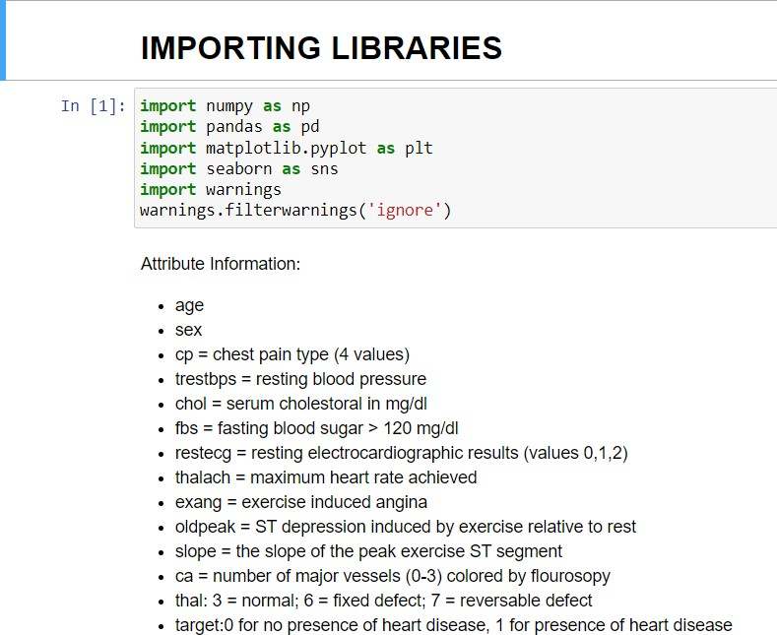

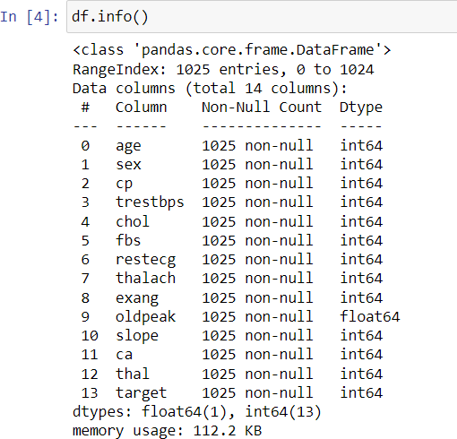

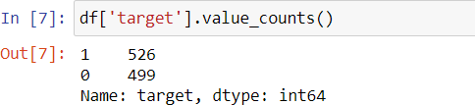

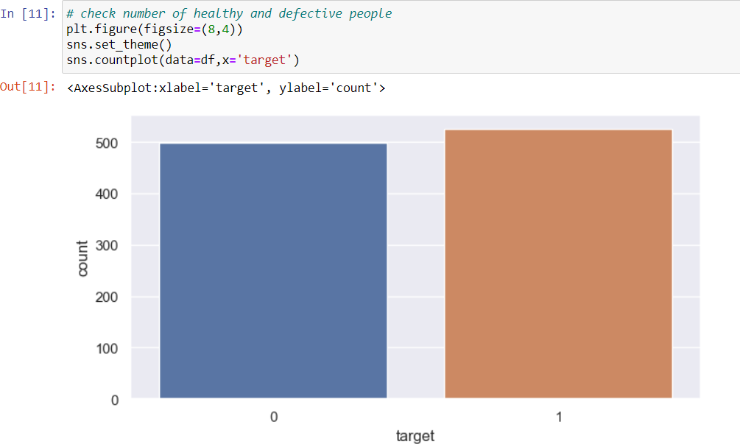

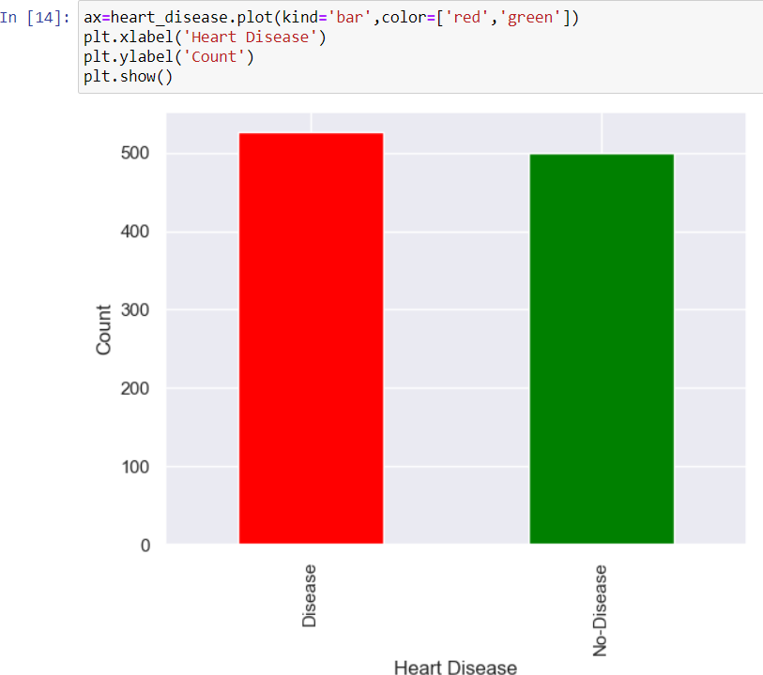

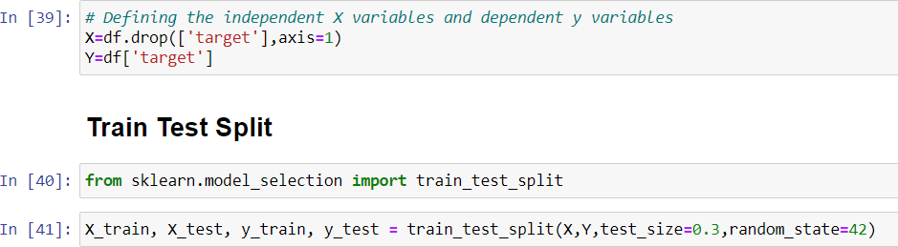

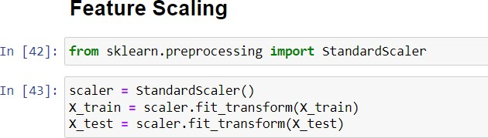

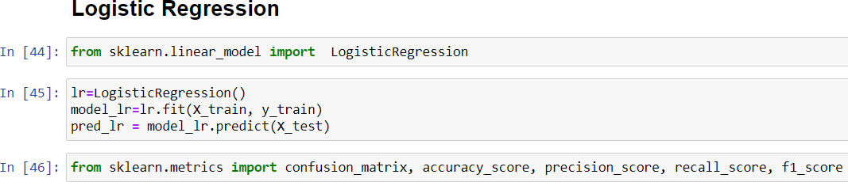

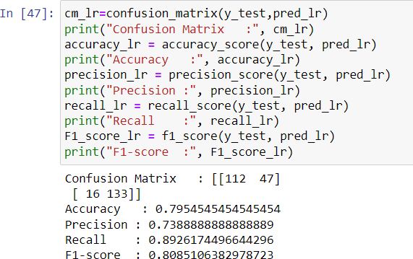

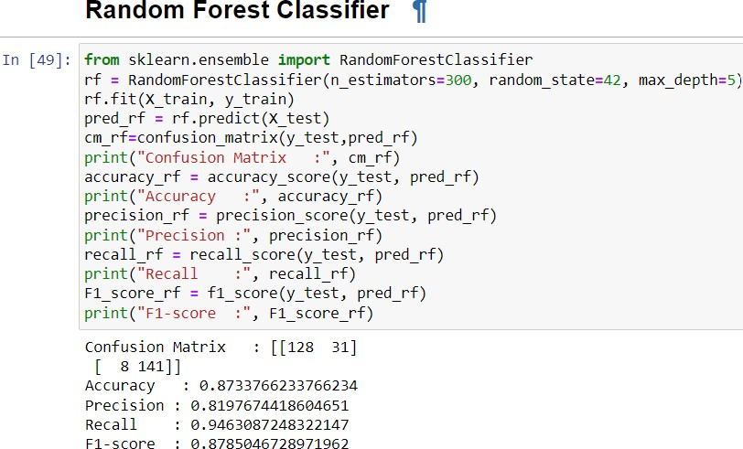



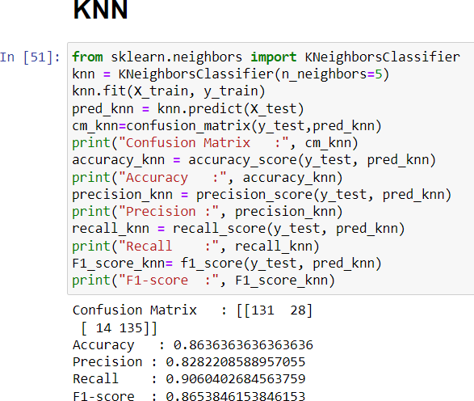

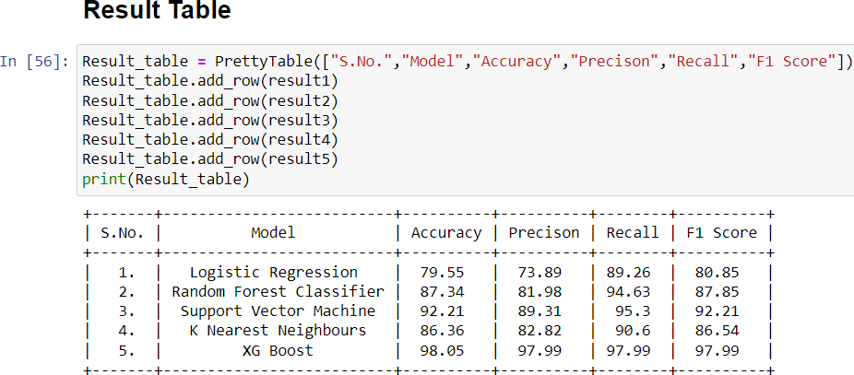

## Business Model:

Some ideas for monetization of CardioCare-

* Integration with Wearable Devices and Monitoring Services-

CardioCare can integrate wearable devices and remote monitoring services. This integration allows users to receive real-time data inputs for accurate cardiac disease classification and monitoring. By forming strategic partnerships with wearable device manufacturers and monitoring service providers, CardioCare can generate revenue through referral commissions or licensing agreements. These partnerships enable users to easily connect their wearable devices or access remote monitoring services directly through the CardioCare platform, enhancing the overall user experience and expanding the revenue streams for the application.

Wearable healthcare technology has grown in popularity over the last few years. With advancements in biosensor technology and accuracy, smaller battery sizes, and increased performance, wearable medical technology can provide users with accurate healthcare data that keeps them in charge of their own healthcare. Remote Monitoring devices such as Blood pressure monitors, Glucose meters, ECG monitors, Fitness trackers, Integrated Active wear and so on.

According to “The International Data Company” (IDC) defines five categories of wearables: watches, wristbands, clothing, ear wear, and others. Accordingly, we include and exclude devices that are:

* + Inclusion:
  1. worn on body, including wrist, waist, arm, foot, and chest,
  2. measuring at least one toxic/hazardous air pollutant,
  3. monitoring zero to more parameters from the behavioral, physiological, or psychological domains,
  4. systems of wearables using WBAN, garments, boots, gloves, and helmets,
  5. providing multiple carrying modes (e.g., attachments to bicycles, backpacks, etc.), as well as wearability.
  + Exclusion:

1. handheld, portable, or stationary,
2. measuring behavioral, hysiological, and/or psychological but not environmental parameters.

* Allow Branding Opportunities-

By offering sponsored sections or customized interfaces where companies can showcase their logos, products, or services. With these branding opportunities CardioCare can generate additional revenue through advertising or sponsorship agreements. We can place personalizedad feeds in compliance with the application’s interface and refraining from distracting and irrelevant spam advertising. It involves the strategic

collaborations, content creation, and marketing campaigns. Also, maintaining ethical standards and safeguarding data privacy is of utmost importance throughout these initiatives.

In-App Purchases-

CardioCare can offer premium health education materials, personalized workout plans, or nutritional guides. These purchases can help improve their health, lifestyle, enhance the user experience and provide a revenue stream. The app can also offer features such as early disease detection, wellness tips, articles, videos or webinars.

* Affiliate Marketing-

Partner with relevant healthcare products and service providers and earn commission fees for referring users to their offerings. For example, health supplements, monitoring devices, nutrition guides, coaches, and fitness equipment. It can also include collaboration with the health influencers or experts in the wellness field which can amplify branding efforts which can reach to wider range of audience that is interested in health-conscious living.

* Integrating Telemedicine-

By integrating with telemedicine platforms or partnering with telemedicine service providers, CardioCare can offer a comprehensive solution for remote cardiac disease diagnosis. This caninvolve revenue-sharing arrangements or referral partnerships with telemedicine providers or nearby healthcare providers. It offers Comprehensive health insights, medical validation, real- time consultation, user convenience, collaborative approach, personalized treatment plans, medical expertise and many more0.

# Affiliate Marketing Model

Partner with relevant healthcare products and service providers and charge them commission fees for promotion of their products and services. For example, health supplements, monitoring devices, nutrition guides, coaches, and fitness equipment

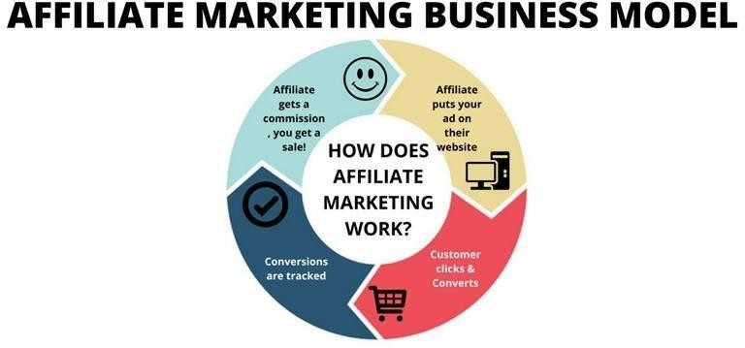

supplements, monitoring devices, nutrition guides, coaches, and fitness equipment

# 1) Advertising Model

We can generate additional revenue through advertising or sponsorship agreements.

# 1) Direct Sales Business Model

We can offer In-App purchases and can subsequently apply the Direct Sales business modeling on those purchases for reaching the desired section of the consumer. In-App purchases that can be offered are health education materials, personalized workout plans,or nutritional guides etc.

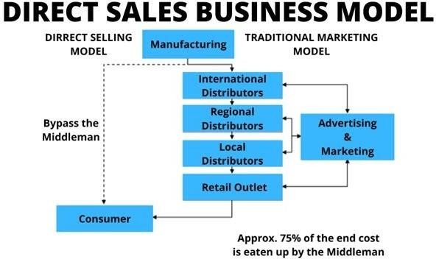

## Final Product Prototype(abstract):

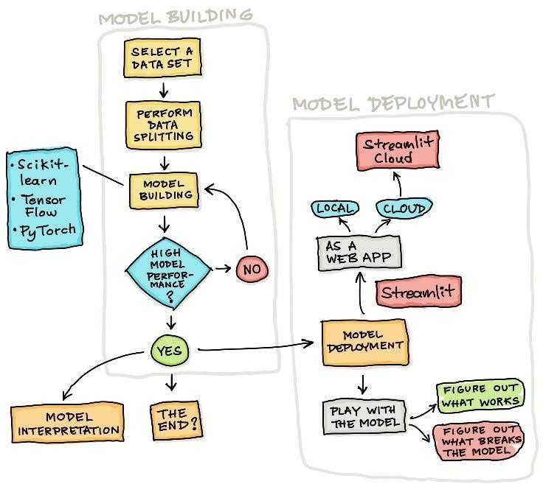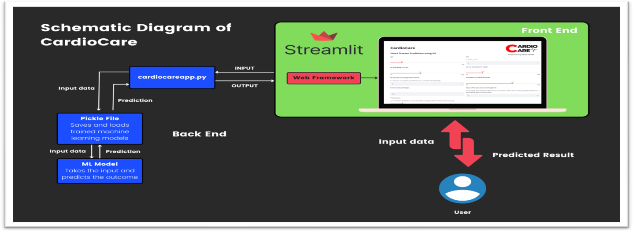

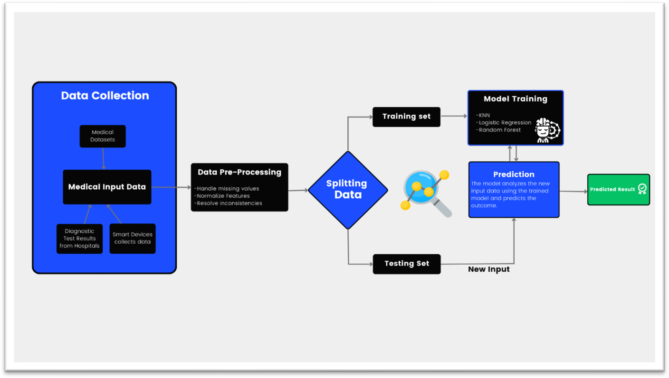

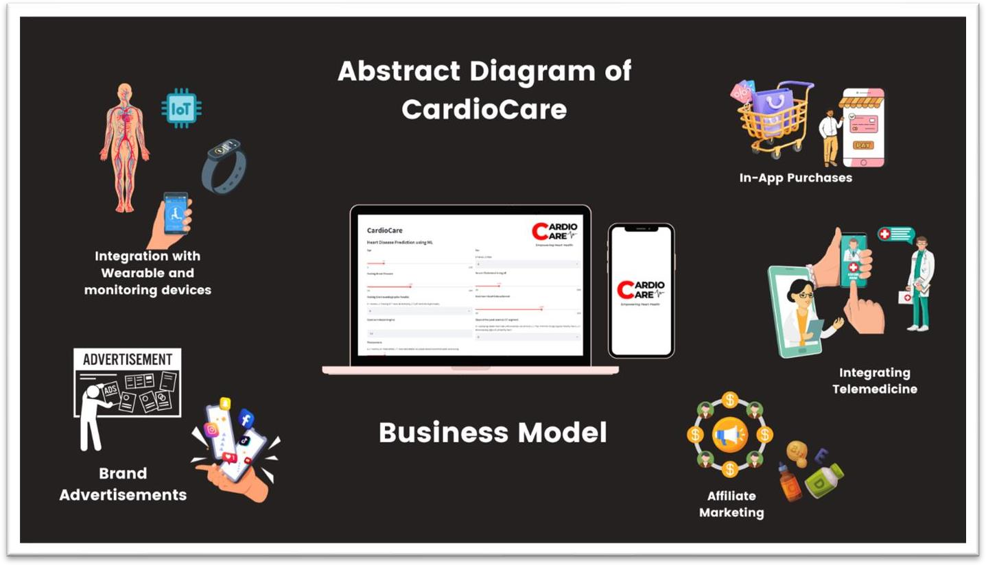

**Estimated Profit Equation:**

Total Development Costs = Development Team + Technology Stack and Tools + Data Collection and Processing + Cloud Services and Hosting + Integration with Wearable Devices + Telemedicine Integration

Using guesstimate, we have drafted the following budget.

1. Research and Development:
   * Development Team (Salaries and Outsourcing): Rs. 70,000
   * Technology Stack and Tools: Rs. 15,000
   * Data Collection and Processing: Rs. 10,000
   * Cloud Services and Hosting: Rs. 10,000
   * Integration with Wearable Devices: Rs. 8,000
   * Telemedicine Integration: Rs. 12,000
   * Total Development Costs: Rs. 1,25,000
2. Legal and Regulatory Compliance:
   * Legal Consultation and Documentation: Rs. 15,000
   * Compliance Costs: Rs. 5,000
   * Total Legal Costs: Rs. 20,000
3. Raw Materials:
   * Collaborations with pharmacy
   * Collaborations with medical devices
   * Collaborations with supplement products
4. Infrastructure:
   * Workplace rent: Rs. 20,000 monthly
5. Marketing & Promotions:
   * Social media promotions: Rs. 15,000 monthly
   * Advertisements: Rs. 20,000 monthly
6. Maintenance and Updates:
   * Ongoing Maintenance: Rs. 20,000
   * Regular Updates and Improvements: Rs. 15,000
   * Total Maintenance Costs: Rs. 35,000

## Revenue Plan:

Revenue from Integration with Wearable Devices: Rs. 3,00,000 per year Revenue from Branding and Sponsored Content: Rs. 25,00,000 per year Revenue from In-App Purchases (Premium Features): Rs. 20,00,000 per year Revenue from Affiliate Marketing: Rs. 15,00,000 per year

Revenue from Telemedicine Integration: Rs. 10,00,000 per year Total Annual Revenue: Rs. 73,00,000 per year

## Profit Calculation:

Annual Profit = Total Annual Revenue - (Developmental costs) - Total Estimated Costs(Annually) Annual Profit = Rs. 73,00,000 - Rs. 1,25,000 - Rs. (40,000+ 20,000 + 15,000 + 35,000)*12

Annual Profit = Rs. 58,55,000